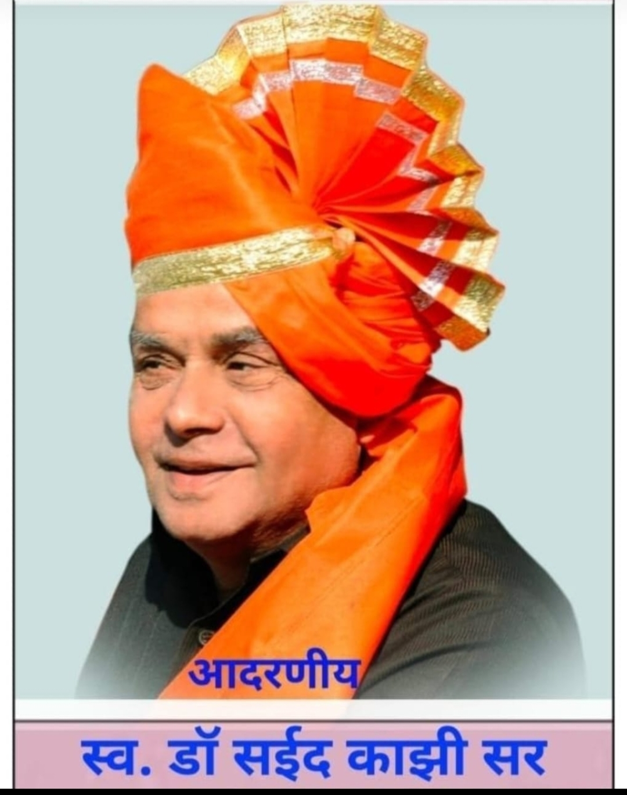

Founder
Late Dr. Saeed Ahmed Kazi
17-12-1952 to 24-4-2020
Doctor by profession
Completed his BHMS from Gune Ayurved College. Ahilyanagr

… 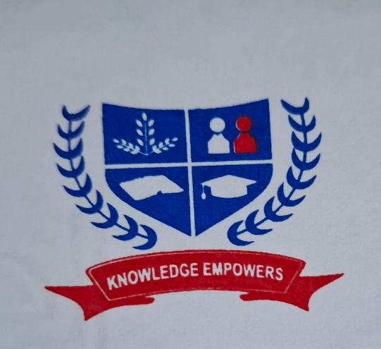
Alfa Social & Educational Foundation
IZAK English Medium School & junior College, Bhalawani
Tal-Parner Dist-Ahilyanagar

About the Institution
Alfa Social and Educational Foundation, Ahmednagar, Registration No. F 8812, is a registered institution and has been granted Minority Status. For the last 24 years, the institution has been working in the health, education, and social sectors in Bhalwani, a remote and drought-affected area of Parner Taluka.
The founder of the institution, Dr. Saeed Ahmed Kazi, began his medical practice at Bhalawani. While practicing medicine, he observed that many children from poor families in the surrounding area were deprived of education. Inspired by the noble belief that education is like the milk of a tigress and should be accessible to every section of society, Dr.Saeed Ahmed Kazi brought quality education to a remote and tribal area such as Bhalawani in Parner Taluka. He has become a strong pillar of support for the students of this region.
In 2004, the IZAK English Medium School was started at Bhalwani with all necessary physical facilities. The school provides education from Standard Nursery to Standard 12, and more than 2,500 students are receiving education in English medium. Separate, well-equipped hostels for boys and girls are available for the accommodation of students.
The State Government has recognized the school as a reputed English-medium school and has sent approximately 550 students belonging to Scheduled Tribes to study there. Due to the provision of quality education to students from rural areas, the school has achieved a 100% pass percentage in Standards 10 and 12. Many students have passed with distinction and have gone on to work as doctors, engineers, lawyers, IT professionals, and government officers.
In the competitive era, continuous efforts are being made to help students progress in all fields. Education and training are provided according to students' interests in arts, sports, cultural activities, competitive examinations, and technical education. Every year, students achieve success at the state level in sports competitions.
Due to the vision of Dr. Saeed Kazi, large and quality educational campuses have today been established in remote and drought-affected areas such as Dhawalpuri and Bhalawani. Approximately 300 to 350 employees from different communities are working at these campuses.
The small sapling planted in the form of a primary Ashram School has today grown into a huge banyan tree. Dr. Saeed Ahmed Kazi is regarded as a strong pillar of support for the educationally deprived people belonging to nomadic and denotified communities, not only in Dhawalpuri and its surrounding areas but throughout Maharashtra.

“ Members Of Management “

President
Mr. Shahid saeed Kazi
DOB 28-5-1986
Qualifications : MAster of
computer application MCA


Secretary
Mr. Rehan shafi Kazi
DOB 11-9-78
Qualifications : Bachelor of Arts
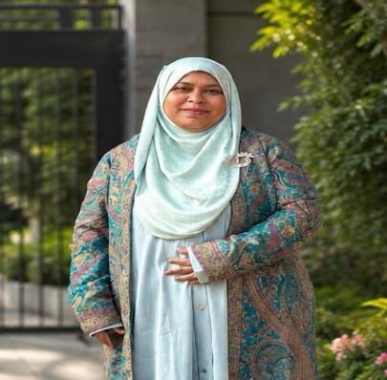
Director
Dr. Asma Shahid Kazi
DOB 4 -10 -1987
Qualifications : BPTh. DNE
Bachelor of physiotherapy
Diploma in Nutrition Education

IZAK ENGLISH MEDIUM SCHOOL, Bhalwani
About Classes
Primary (1st to 5th)

- Class 1st
Class 1st is an important beginning of a child’s formal education, where students develop essential academic skills and positive learning habits. This service provides comprehensive tutoring in subjects such as Mathematics, English, Environmental Studies, and other subjects prescribed by the respective educational boards.
Experienced instructors use engaging and age-appropriate teaching methods to help students develop basic reading, writing, counting, and problem-solving skills. Regular activities, practice sessions, assessments, and personalized attention help students build confidence and develop a strong foundation for future learning.

Class 2nd is an important stage for strengthening the basic concepts developed in the early years of education. This service provides comprehensive tutoring in subjects such as Mathematics, English, Environmental Studies, and other subjects prescribed by the respective educational boards.
- Class 2nd
Experienced instructors provide personalized attention and interactive learning methods to improve students’ reading, writing, mathematical, and problem-solving abilities. Regular practice, activities, assessments, and feedback help students strengthen their concepts and develop greater confidence in their studies.

Class 3rd is a key stage in a student’s academic development, where learners begin to build deeper understanding and apply their knowledge to different situations. This service provides comprehensive tutoring in subjects such as Mathematics, English, Environmental Studies, and other subjects prescribed by the respective educational boards.
- Class 3rd
Experienced instructors focus on conceptual understanding, reading comprehension, writing skills, numerical ability, and logical thinking. Regular assessments, practice exercises, doubt-solving sessions, and personalized guidance help students improve their academic performance and develop strong learning habits.

Class 4th plays an important role in strengthening fundamental concepts and preparing students for more advanced learning. This service provides comprehensive tutoring in subjects such as Mathematics, English, Environmental Studies, and other subjects prescribed by the respective educational boards.
- Class 4th
Experienced instructors provide personalized guidance with a focus on conceptual clarity, problem-solving, language development, and effective learning techniques. Regular assessments, practice sessions, activities, and feedback help students strengthen their knowledge and approach their examinations with confidence.

Class 5th is an important stage that prepares students for the transition to higher classes and more advanced academic concepts. This service provides comprehensive tutoring in subjects such as Mathematics, English, Environmental Studies, Science, and other subjects prescribed by the respective educational boards.
- Class 5th
Experienced instructors provide focused and personalized attention to strengthen conceptual understanding, analytical thinking, problem-solving skills, and subject knowledge. Regular assessments, mock tests, revision sessions, doubt-solving, and constructive feedback ensure that students are well-prepared for their examinations and develop a strong foundation for secondary education.

IZAK ENGLISH MEDIUM SCHOOL, Bhalwani
About Classes
Secondary (6st to 8th)

Class 6 refers to the educational curriculum designed for students in the sixth grade, typically around 11 to 12 years old. This stage is crucial as it builds foundational skills in various subjects including mathematics, science, language arts, and social studies. The curriculum often emphasizes critical thinking, problem-solving, and creativity, encouraging students to engage actively with the material. Class 6 also introduces more complex concepts and projects, aiming to prepare students for higher grades while fostering a love for learning.
- Class 6

Class 7 services typically include a range of educational support tailored for students in this crucial stage of their academic journey. These services encompass personalized tutoring in core subjects such as mathematics, science, and language arts, aimed at reinforcing foundational knowledge and enhancing critical thinking skills. Additionally, extracurricular activities, homework assistance, and test preparation strategies are often part of the offering. Overall, Class 7 services are designed to foster a positive learning environment and promote academic success for students.
- Class 7

Class 8 services refer to specialized offerings for students in the eighth grade, focusing on enhancing their academic skills and personal development. These services often include tutoring in core subjects such as mathematics, science, and language arts, tailored to meet the individual needs of students. Additionally, extracurricular activities like sports, arts, and leadership programs are designed to foster teamwork and creativity. With an emphasis on building a solid foundation for high school, Class 8 services aim to prepare students for future academic challenges while promoting a well-rounded education.
- Class 8

IZAK ENGLISH MEDIUM SCHOOL, Bhalwani
About Classes
Higher Secondary (9st to 12th)

Class 9 encompasses a critical stage in the educational journey, typically for students aged 14 to 15. This grade focuses on foundational subjects like Mathematics, Science, English, and Social Studies, aimed at preparing students for their secondary education and board examinations. The curriculum is designed to enhance analytical thinking. problem-solving skills, and conceptual understanding. Additionally, students may engage in practical experiments, project work, and group discussions, fostering collaborative learning and a deeper grasp of various topics.
- Class 9

Class 10 education is a pivotal stage in a student's academic journey, as it prepares learners for higher secondary education and lays the groundwork for future studies. This service encompasses comprehensive tutoring in essential subjects such as Mathematics, Science, and English, focusing on the syllabus prescribed by educational boards. Experienced instructors provide personalized attention, facilitating conceptual understanding and problem-solving skills. Regular assessments, mock exams, and feedback sessions are integral to this service, ensuring students are well-prepared for their board examinations.
- Class 10

Class 11th is a crucial stage in a student’s academic journey, as it marks the transition to higher secondary education and builds a strong foundation for future academic and career goals. This service provides comprehensive tutoring in essential subjects such as Mathematics, Physics, Chemistry, Biology, and English, based on the syllabus prescribed by the respective educational boards.
- Class 11th
Experienced instructors provide personalized guidance, focusing on conceptual clarity, analytical thinking, problem-solving skills, and effective study techniques. Regular assessments, practice tests, doubt-solving sessions, and feedback help students strengthen their understanding and prepare confidently for Class 11 examinations as well as competitive entrance examinations.

Class 12th is a significant milestone in a student’s academic journey, preparing learners for board examinations, higher education, and competitive entrance examinations. This service offers comprehensive tutoring in key subjects such as Mathematics, Physics, Chemistry, Biology, and English, following the syllabus prescribed by the respective educational boards.
- Class 12th
Experienced instructors provide personalized attention and focused guidance to strengthen conceptual understanding, improve problem-solving abilities, and develop effective examination strategies. Regular assessments, mock examinations, doubt-solving sessions, revision programs, and constructive feedback ensure that students are thoroughly prepared to achieve their academic goals and perform confidently in board and competitive examinations.

